Time Management

Career & Life Education 9

BIG IDEA
- Finding a balance between work and personal life is essential to good physical and mental health

CURRICULAR COMPETENCIES
- Employability skills
- Recognize the need for a healthy balance between school and other life activities

Save this file as
“TIME_YOUR FULLNAME.docx”

Record all your answers below in blue

When you are done, email it to wablitt@sd35.bc.ca

- How would you describe your time management strategies? Are you super organized? Do you keep a detailed calendar? How do you stay organized? Do you rely on your memory or the reminders from other people? Do you procrastinate? Do you pretend that your obligations don’t exist in the hopes that they will somehow “go away”? Do you let things pile up on you? Write three or four sentences on how you organize your obligations in and out of school.

- What are your big time-wasters? YouTube? TV? Netflix? Gaming?

- What kind of things to you tend to say “yes” to, then regret later when you have to follow through?

- What kind of tasks do you value? Time with family? Friends? Reading a good book? Physical activity?

- Look up a definition for “procrastination” and paste it below.

- Look up a definition for “prioritize” and paste it below.

- List 8 things that you need to get done this week

Think of those things in the following quadrant to help prioritize them

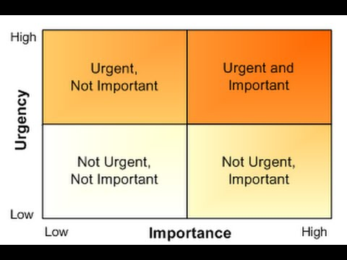

- Now re-prioritize your list with these labels. Which of your tasks are:

Urgent, but not important:

Urgent, and important:

Not urgent, and not important:

Not urgent, but important:

